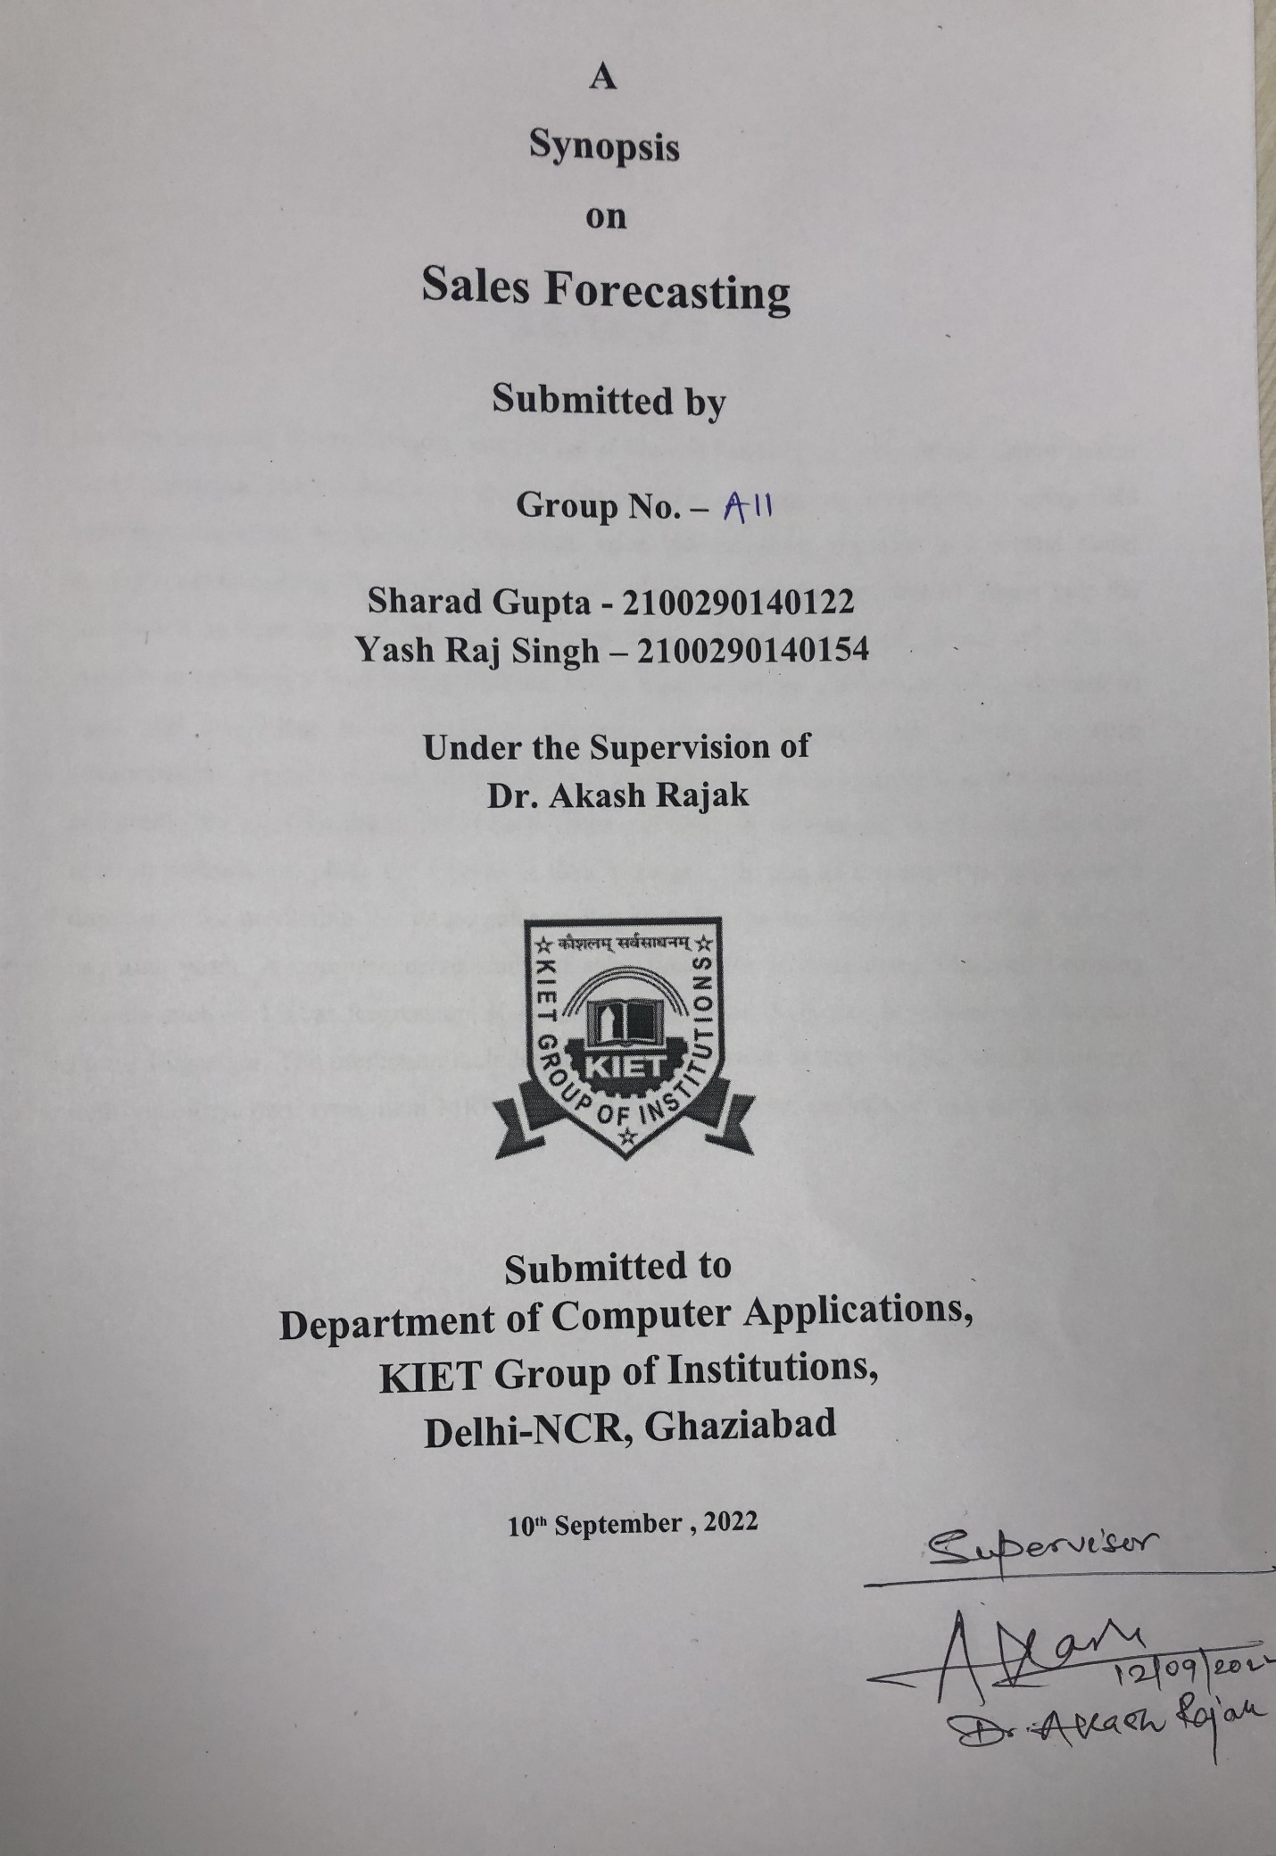

**ABSTRACT**

Machine Learning is transforming every walk of life and has become a major contributor in real world scenarios. The revolutionary applications of Machine Learning can be seen in every field including education, healthcare, engineering, sales, entertainment, transport and several more; the list is never ending. The traditional approach of sales and marketing goals no longer help the companies, to cope up with the pace of competitive market, as they are carried out with no insights to customers’ purchasing patterns. Major transformations can be seen in the domain of sales and marketing as a result of Machine Learning advancements. Owing to such advancements, various critical aspects such as consumers’ purchase patterns, target audience, and predicting sales for the recent years to come can be easily determined, thus helping the sales team in formulating plans for a boost in their business. The aim of this paper is to propose a dimension for predicting the future sales of Big Mart Companies keeping in view the sales of previous years. A comprehensive study of sales prediction is done using Machine Learning models such as Linear Regression, K-Neighbors Regressor, XGBoost Regressor and Random Forest Regressor. The prediction includes data parameters such as item weight, item fat content, item visibility, item type, item MRP, outlet establishment year, outlet size and outlet location type.

**TABLE OF CONTENTS**

1. Introduction
2. Libraries
3. Hardware requirement
4. Software Requirements
5. Benefits
6. Results
7. Gantt Chart
8. Conclusion

**INTRODUCTION**

Sales forecasting has always been a very significant area to concentrate upon. An efficient and

optimal way of forecasting has become essential for all the vendors in order to sustain the efficacy of the marketing organizations. Manual infestation of this task could lead to drastic errors leading to poor management of the organization, and most importantly would be time consuming, which is something not desirable in this expedited world. A major part of the global economy relies upon the business sectors, which are literally expected to produce appropriate quantities of products to meet the overall needs.

Targeting the market audience is the major focus of business sectors. It is therefore important that the company has been able to achieve this objective by employing a system of forecasting. The process of forecasting involves analyzing data from various sources such as market trends, consumer behavior and other factors. This analysis would also help the companies to manage the financial resources effectively. The forecasting process can be used for many purposes, including: predicting the future demand of the products or service, predicting how much of the product will be sold in a given period.

This is where machine learning can be exploited in a great way. Machine learning is the domain where the machines gain the ability to outperform humans in specific tasks. They are used to do some specialized task in a logical way and gain better results for the progress of the current society. The base of machine learning is the art of mathematics, with the help of which various paradigms can be formulated to approach the optimum output. In case of sales forecasting also machine learning has proved to be a boon. It is helpful in predicting the future sales more accurately.

**LIBRARIES TO BE USED**

Numpy :- Mathematical and logical operations are performed with the help of NumPy.

Pandas :- Pandas is a software library that is designed for manipulating the data and analysis in a python programming language.

Matplotlib :- Matplotlib is a module of Python used to plot the attractive Graphs.

SKlearn :- Scikit-learn is a free python library. It features multiple clustering classification and regression algorithms.

Seaborn :- Seaborn is a open-source python library that is used for statistical graphics.

**HARDWARE REQUIREMENTS**

* Hardware specifications required for installing all the required software environment and tools.
* Processor – Intel i3 5th Generation or above
* RAM – Minimum 4GB ,Recommended 8GB or above
* Disk Space – Minimum 20 GB free of disk space

**SOFTWARE REQUIREMENTS**

The software environment to be used in the project is -

* Operating System - Windows 10/11 or any Linux OS
* Code Editor – Jupyter Notebook

**BENEFITS**

* Without sales, a company cannot grow. This is why every company has to consistently bring in new revenue.
* Machine learning can significantly improve the speed of your sales team’s workflow, allowing them to focus on the most qualified opportunities.
* Machine learning can help by providing new insights into customer behavior and patterns.
* The ultimate goal of selling more is to do it more efficiently, without having to invest a lot of money into hiring more salespeople.

**RESULTS**

* Machine Learning algorithms such as Linear Regression, KNearest Neighbors algorithm, XGBoost algorithm and Random Forest algorithm have been used to predict the sales of various outlets of the Organization. Various parameters such as Root Mean Squared Error (RMSE), Variance Score, Training and Testing Accuracies which determine the precision of results are tabulated for each of the four algorithms.

**CONCLUSION**

* With traditional methods not being of much help to the business organizations in revenue growth, use of Machine Learning approaches prove to be an important aspect for shaping business strategies keeping into consideration the purchase patterns of the consumers. Prediction of sales with respect to various factors including the sales of previous years helps businesses adopt suitable strategies for increasing sales and set their foot undaunted in the competitive world

**GANTT CHART**

